**JOBSHEET 1**

Web Server Installation and Basic HTML

Agna Putra Prawira (2341720065 )

Class 2I / 01

**STUDY PROGRAM D-IV TEKNIK INFORMATIKA**

**INFORMATION TECHNOLOGY MAJOR**

**POLITEKNIK NEGERI MALANG**

Jl. Soekarno Hatta No. 9 Malang 65144

1. Record the results (question No. 1). Include a screenshot of the display and provide an explanation. Please provide your answer below.

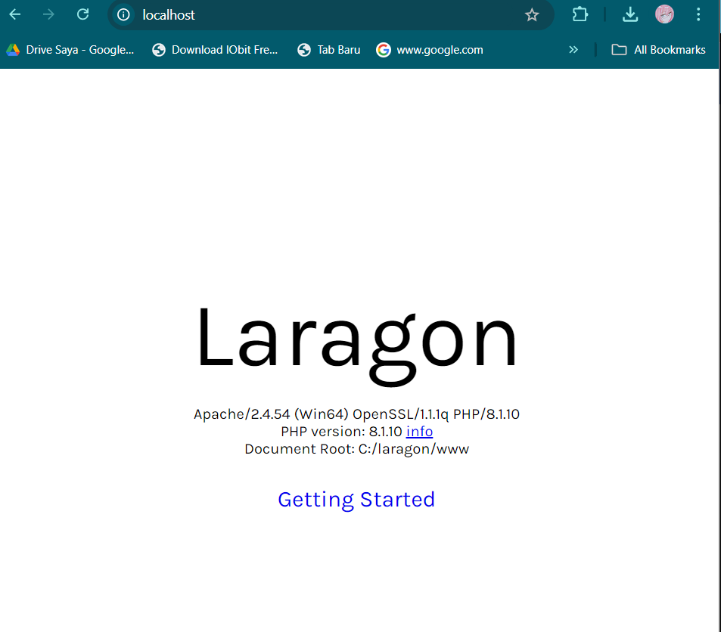

The browser should display the Laragon dashboard or a default page indicating that the local server is running successfully.

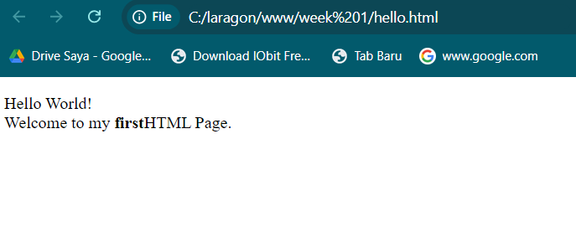2. Record your observations (question No. 2) and write your answer below.3

3. (question No. 3) Write your answer below.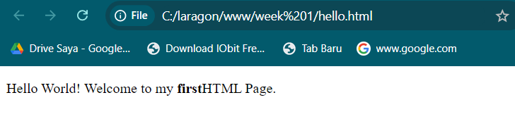

**Function of <br> Tag:** The <br> tag is used to insert a line break in the text, forcing the text after it to appear on the next line.

4. Record your observations (question No. 4) and write your answer below.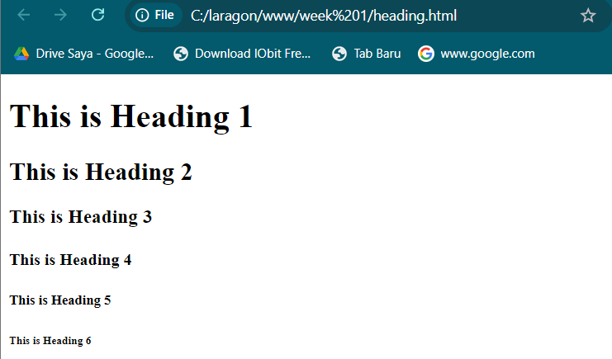

5. Record your observations (question No. 5) and write your answer below

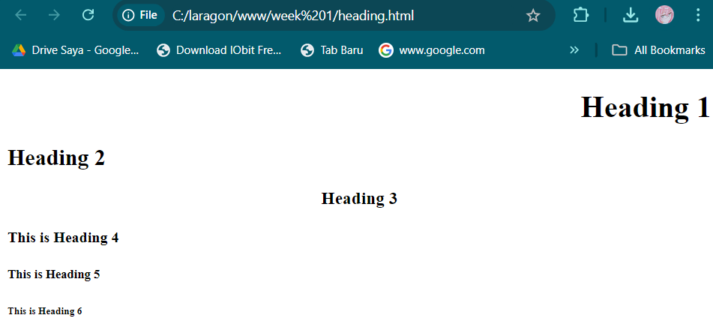

6. Record your observations (question No. 6) and write your answer below.

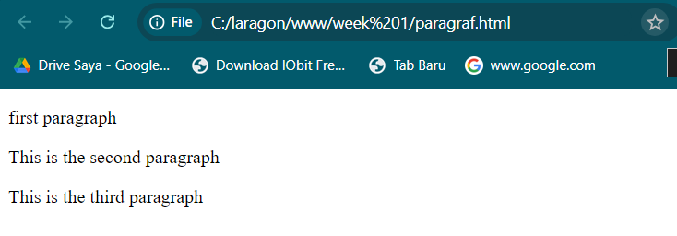

7. Record your observations (question No. 7) and write your answer below

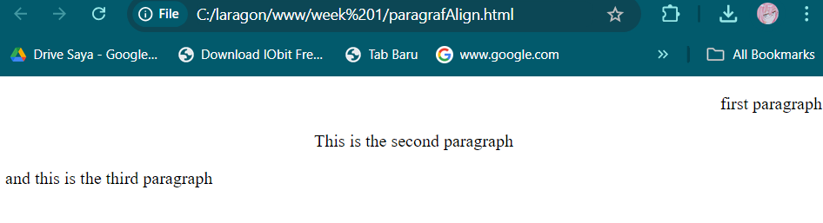

8. Record your observations (question No. 8) and write your answer below.

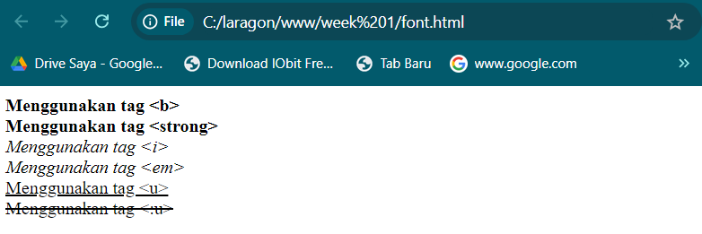

9. Record your observations (question No. 9) and write your answer below

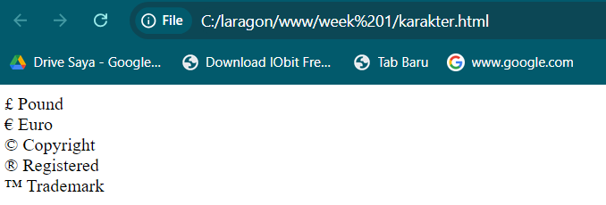

10. Record your observations (question No. 10) and write your answer below

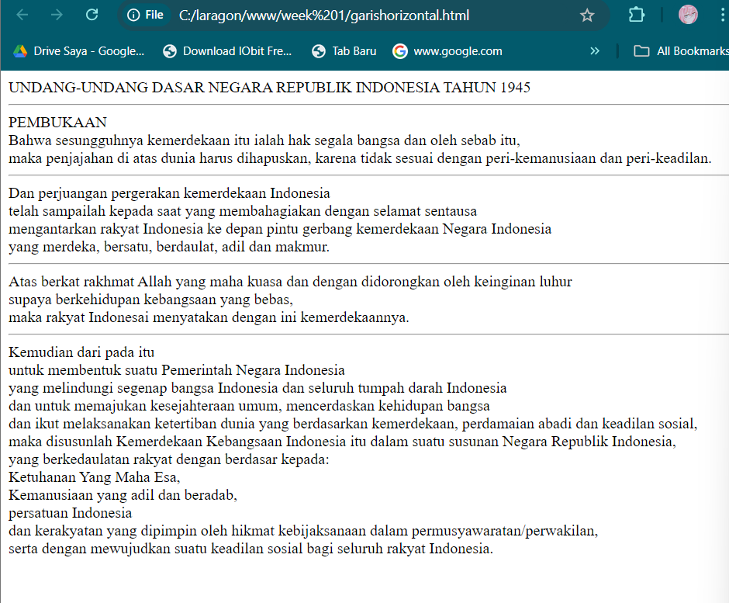

11. Record your observations (question No. 11) and write your answer below.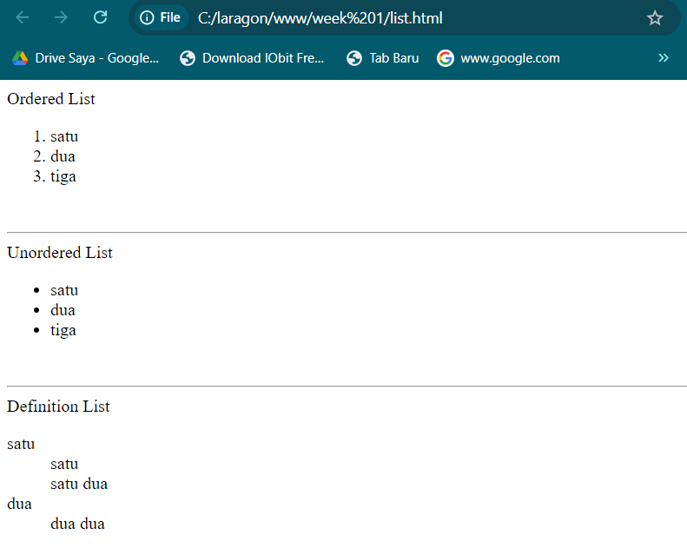

12. Record your observations (question No. 12) and write your answer below

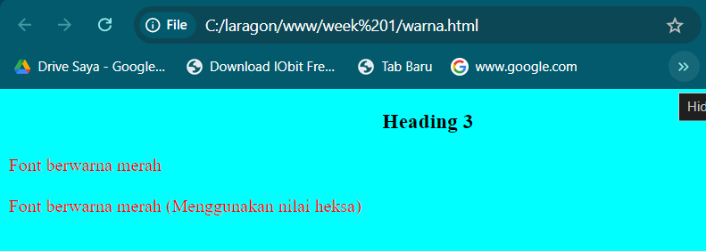

13. Record your observations on the two methods of displaying images on the webpage (question No. 13) and write your answer below.

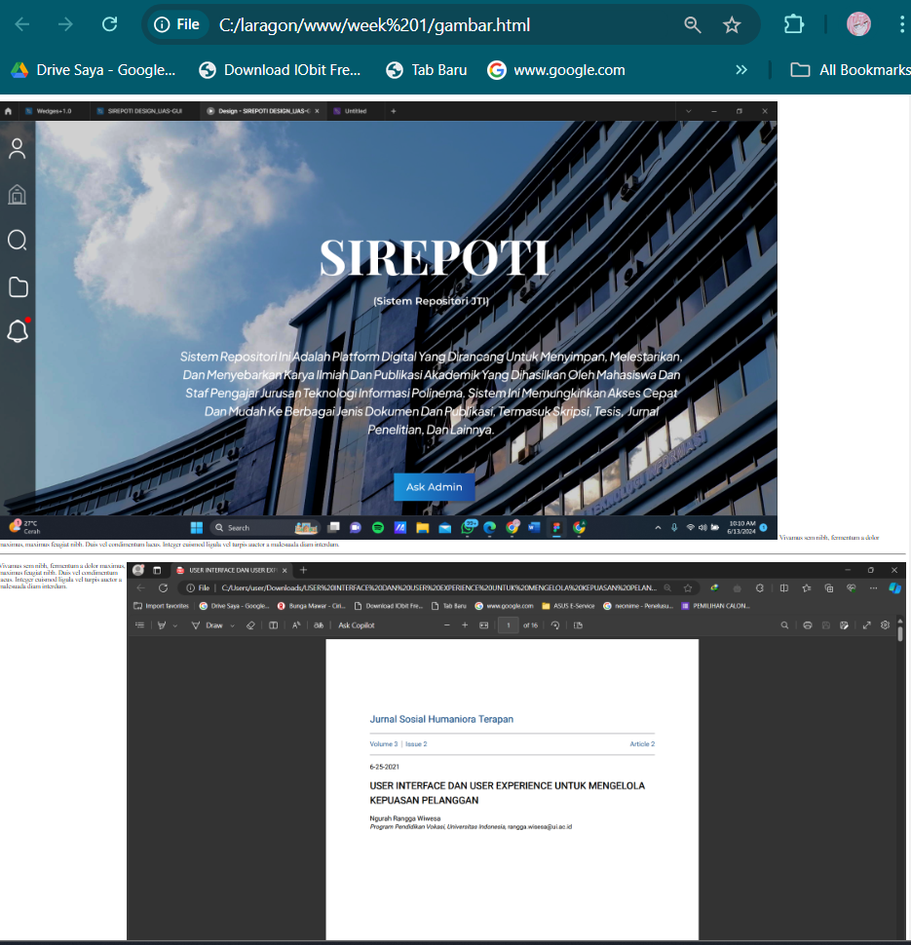

Both methods successfully display images on the webpage. The difference lies in the file path used in the src attribute. When the image is in the same directory as the HTML file, only the file name is needed. When the image is in a subfolder, the relative path to the image file must be provided.

14. Record your observations (question No. 14) and write your answer below.

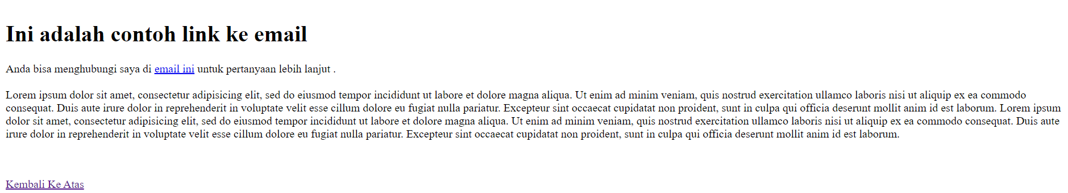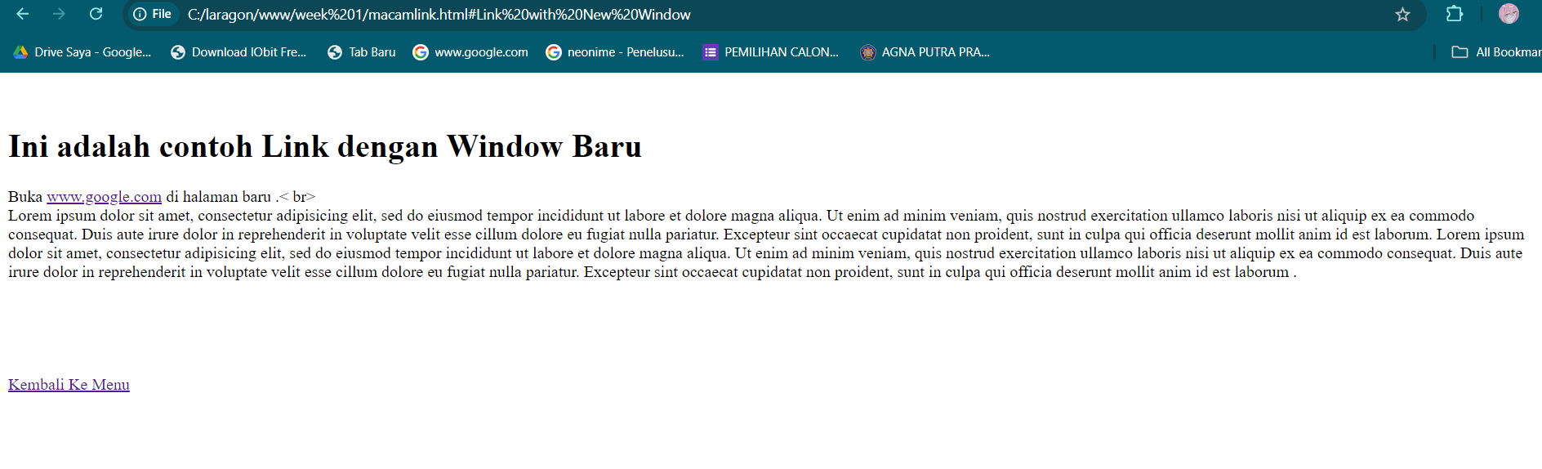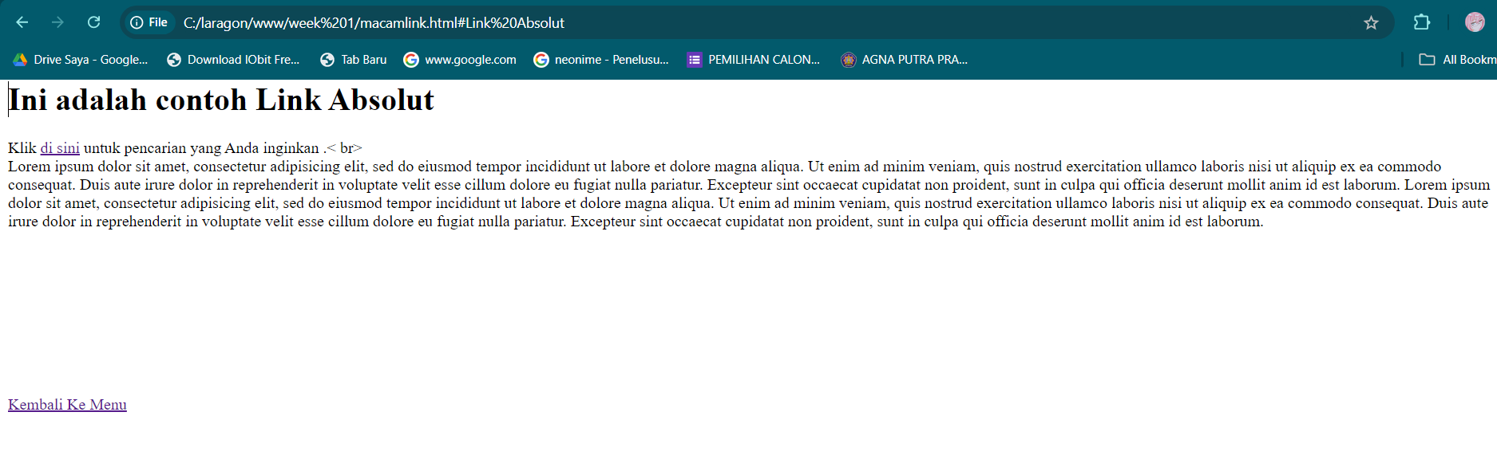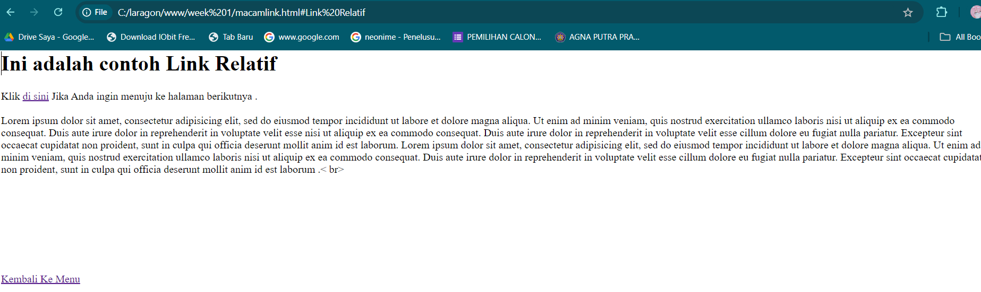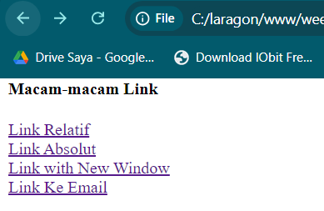

Practical Task Section 10: Links Create a webpage and name it tugasLink.html. Display an image that contains a link to https://www.google.com

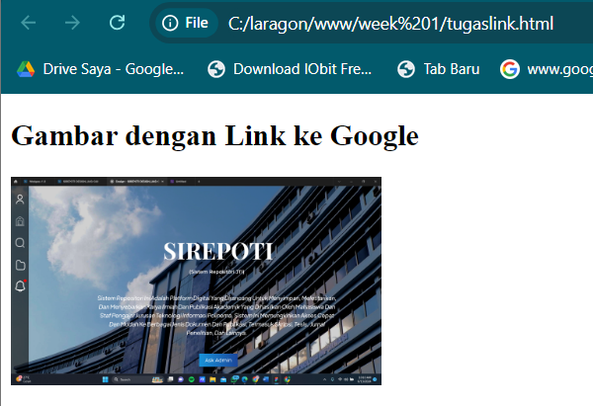

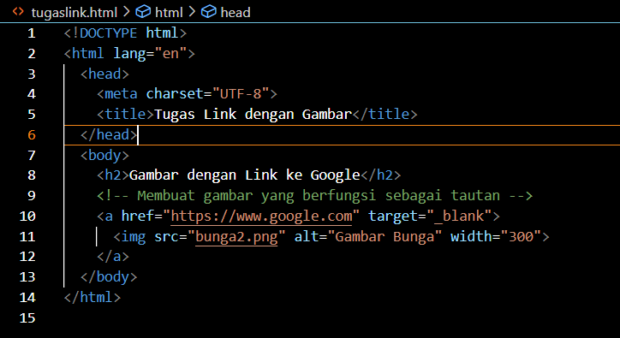15. Record your observations (question No. 15) and write your answer below.

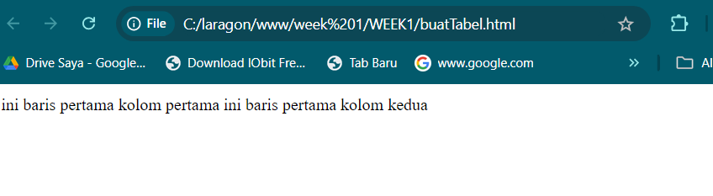

16. Record your observations (question No. 16) and write your answer below.

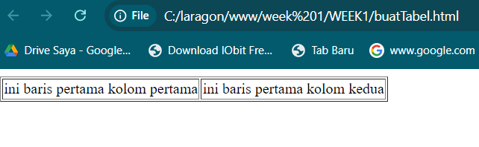

17. Write down the code for the modified buatTabel.html. (question No. 17) and write your answer below.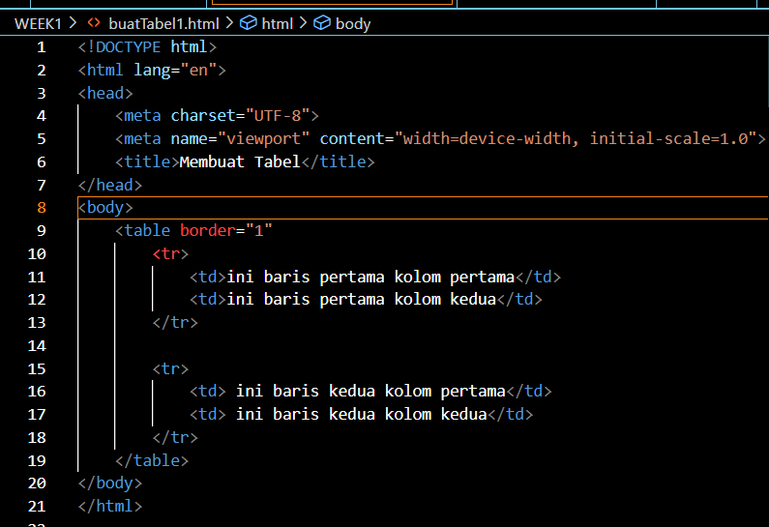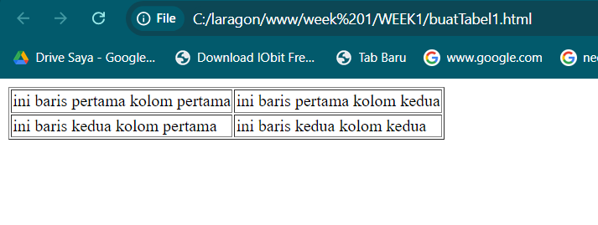

18. Note the changes here (question No. 18) and write your answer below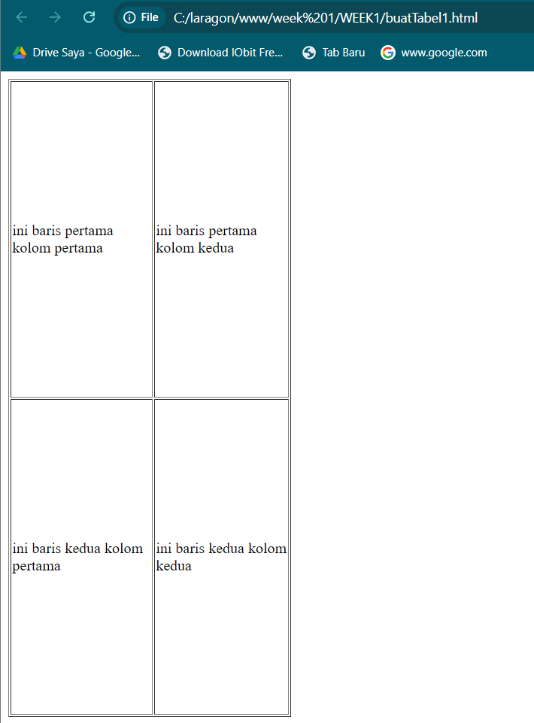

19. What do you understand about the difference between using and omitting % in the code? Note your understanding here (question No. 19) and write your answer below.

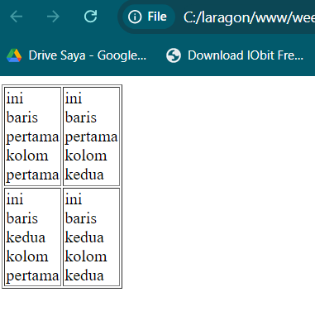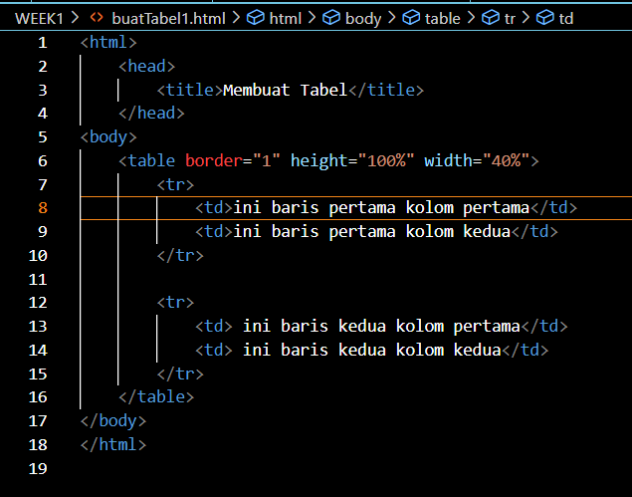

The choice between using and omitting % depends on the desired layout. % is preferred for responsive and flexible designs, while fixed pixel values are suitable when a specific and consistent size is needed regardless of the container's dimensions.

20. Note the changes here (question No. 20) and write your answer below.

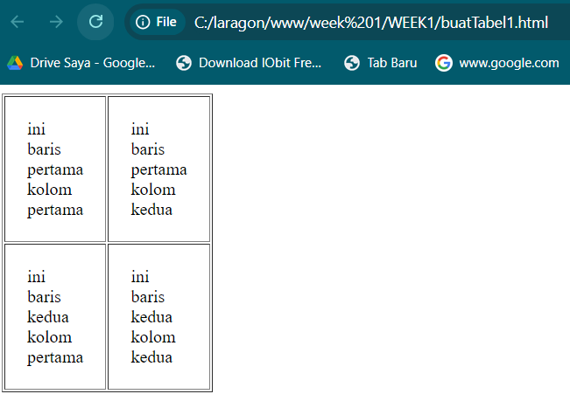

21. Note the changes here (question No. 21) and write your answer below

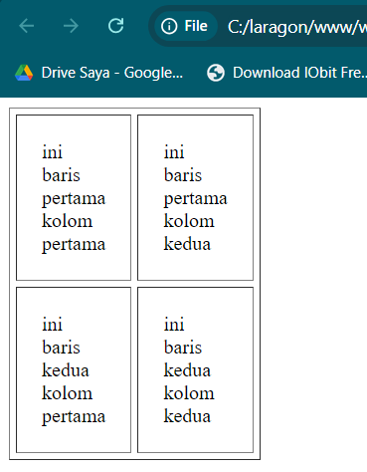

22. Note your observations here (question No. 22) and write your answer below

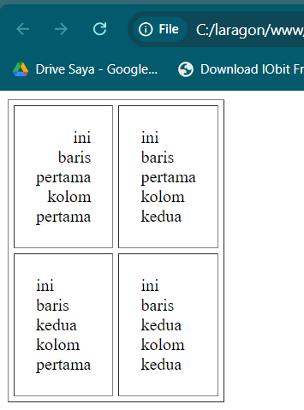

23. Note your observations here (question No. 23) and write your answer below.

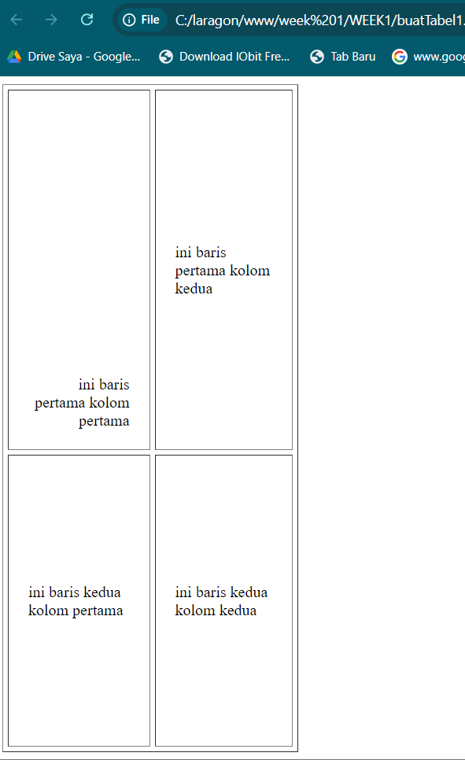

24. Note your observations here (question No. 24) and write your answer below

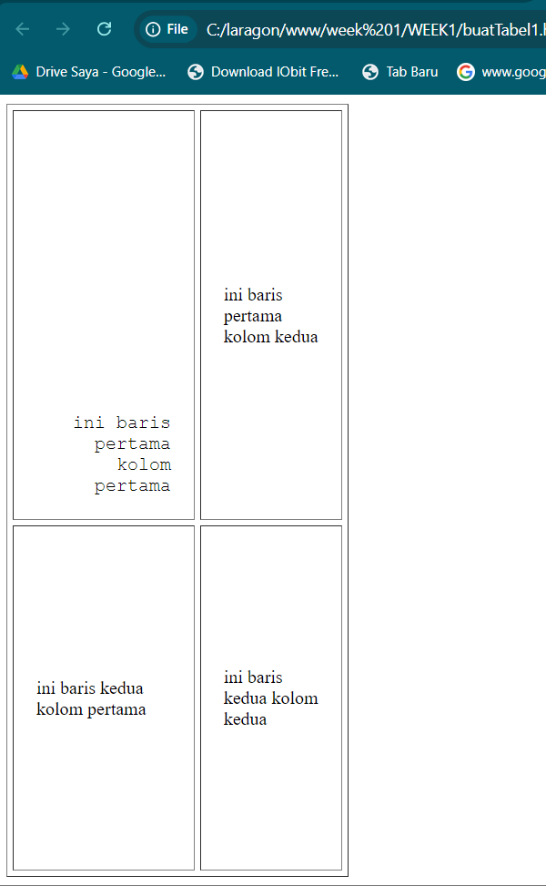

25. Write the modified code from step 34 in the buatTabel.html file here (question No. 25). And write your answer below

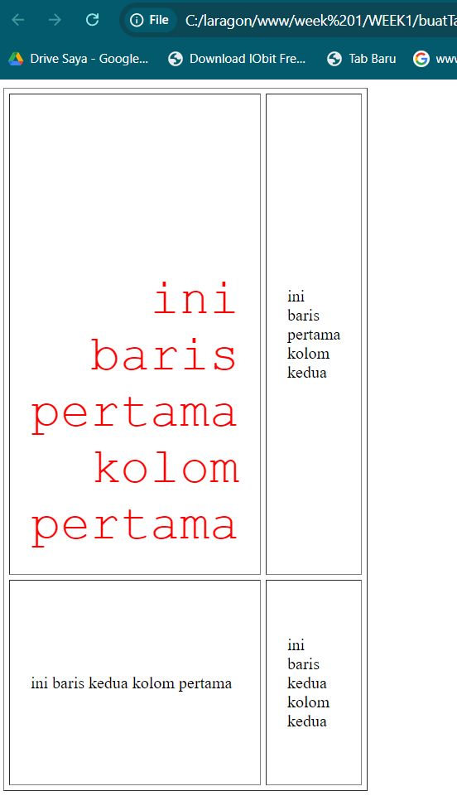

26. (question No 26) Write down your code here

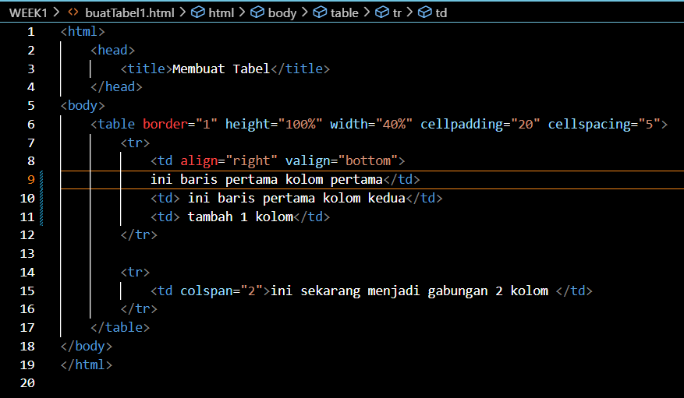

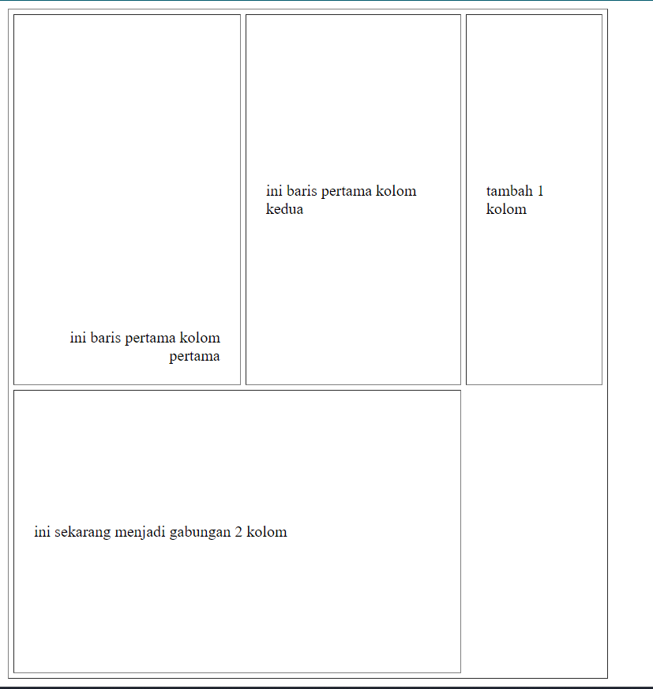

27. (question No 27) Write down your code here

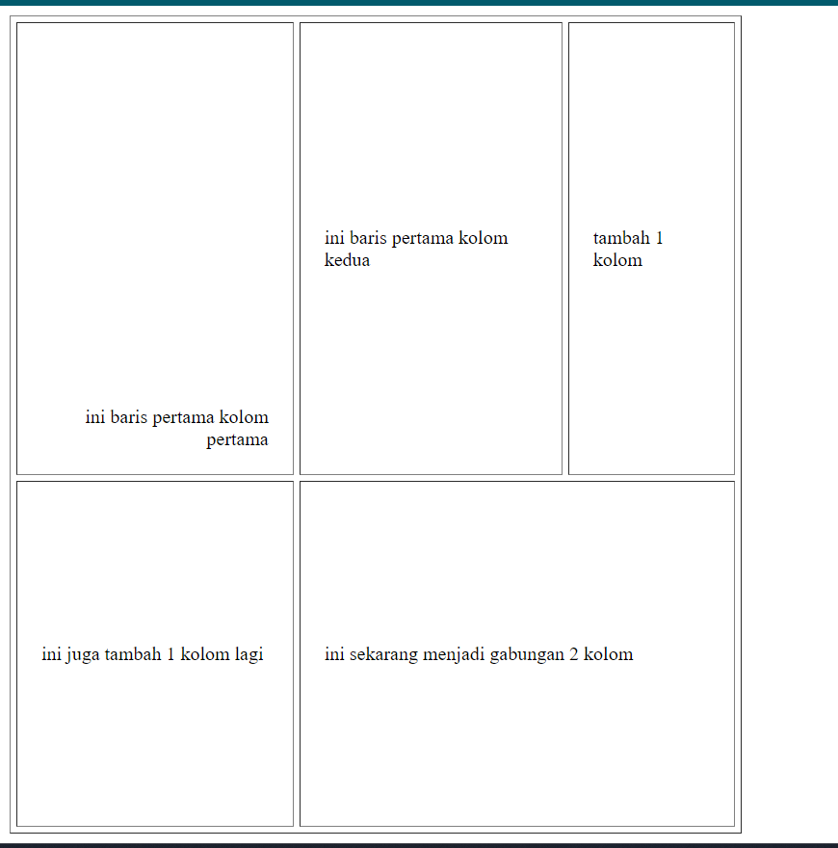

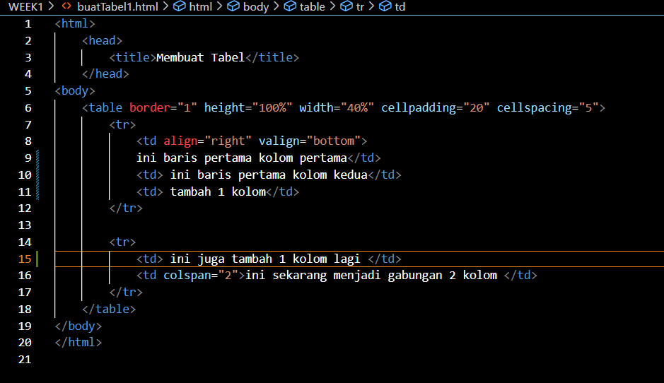

28. Note your observations here (question No. 28) and write your answer below.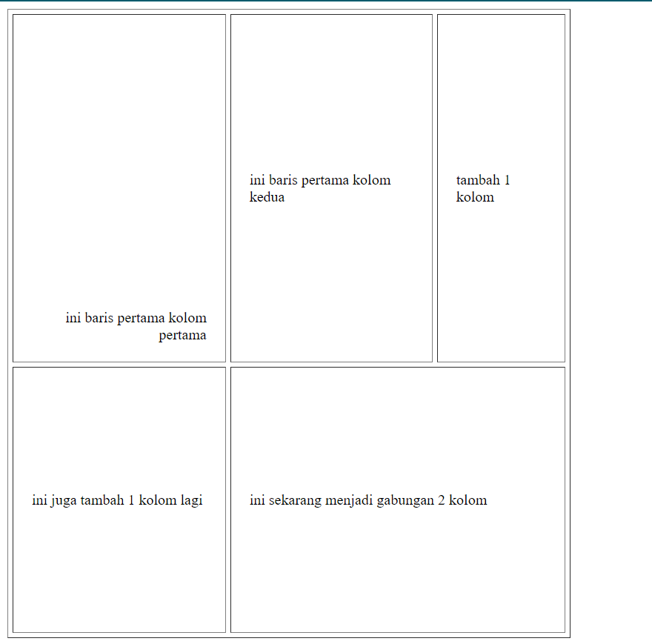

Adding rowspan="2" to the first column of the second row without adding an additional row can lead to formatting issues. The table now expects another row that spans vertically, which is missing in this case, causing an imbalance in the table layout.

29. Note your observations here (question No. 29) and write your answer below.



Moving rowspan="2" from the second row to the first row significantly alters the table's structure, making it more organized and balanced. The table now properly spans the intended rows without leaving any gaps or creating layout issues.

30. Note your observations and understanding here (question No. 30) and write your answer below.

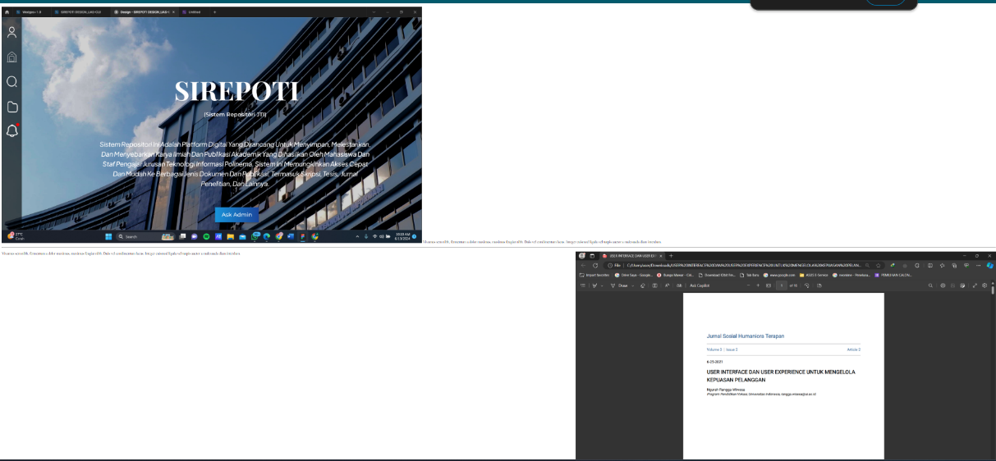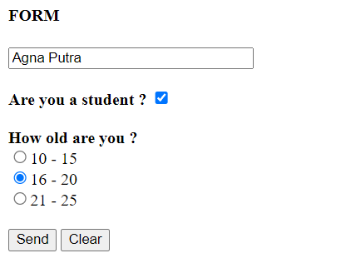

This HTML form is well-structured and demonstrates basic form elements such as text input, checkboxes, and radio buttons. The use of the POST method ensures that the data is sent securely, and the action directs the form submission to the specified page. Understanding how these elements work together is fundamental in web development for capturing and processing user input.

31. Record the code you added in step 7 here (question No. 31) and write your answer below.

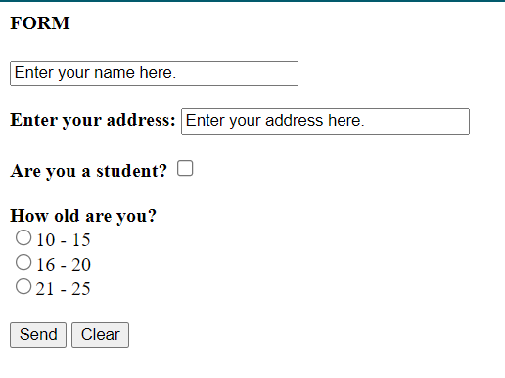

Adding a new input field for the address is straightforward and seamlessly integrates into the form. This exercise demonstrates how to modify a form to collect more information from the user, ensuring that the form remains well-organized and easy to use.

32. Does the display in the browser look like the one shown below? (question No. 32).

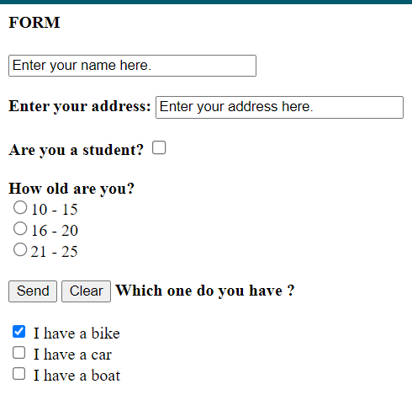

33.Write down here the code for the entire checkbox configuration, including the code for the checkbox you just added. (question No. 33). Write your answer below

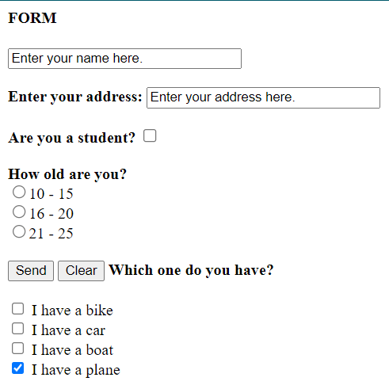

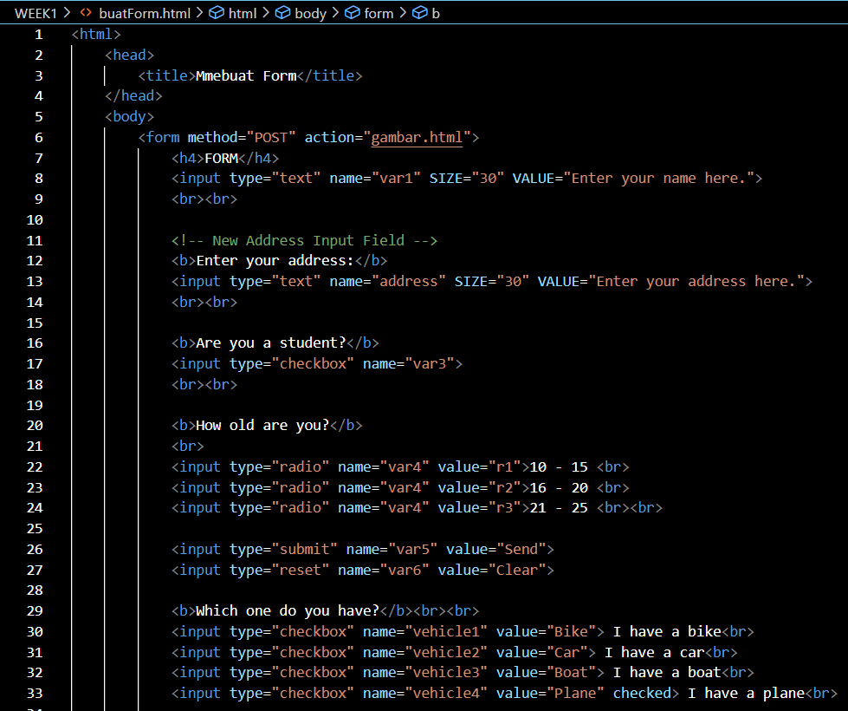34. Note here what the code snippet in step 17 means (how it works). (question No. 34) Write your answer below.

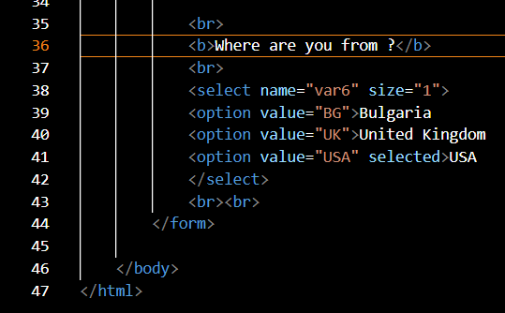

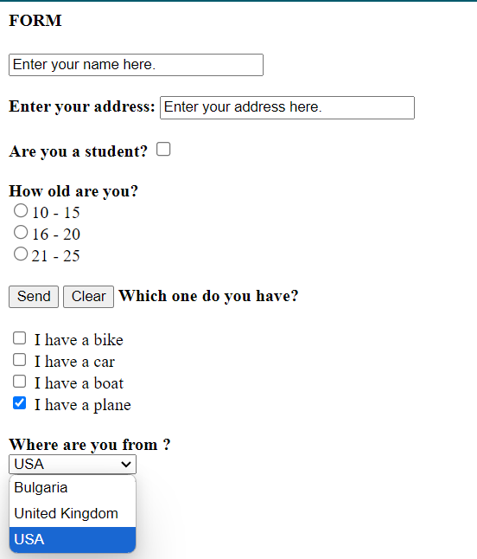

The form is now more comprehensive with additional input fields and options. These changes enhance user interaction by allowing them to select a country from a dropdown list and by adding more vehicle options with appropriate checkmarks. The form layout is well-structured, ensuring ease of use and clarity for the user.

35. Note the changes here (question No. 35) and write your answer below

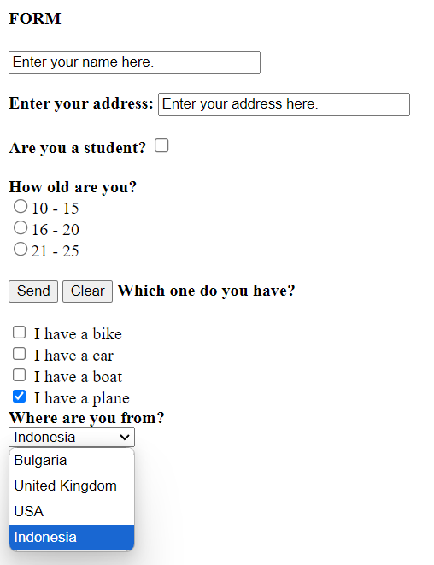

• Added the option <option value="ID" selected>Indonesia</option> to the dropdown menu.

• Set "Indonesia" as the default selected option using the selected attribute.

36. Note the changes here (question No. 36) and write your answer below.

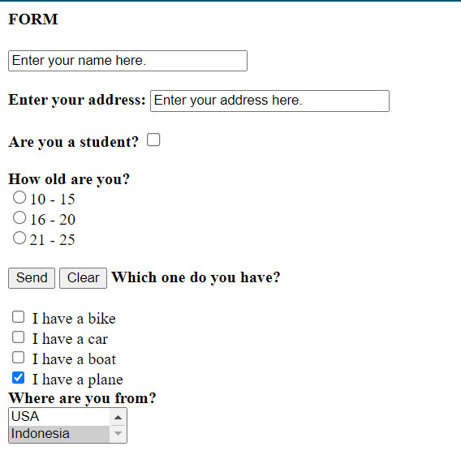

* The size attribute of the <select> element has been changed from size="1" to size="2".

This change modifies the dropdown menu to display two options at a time, making it easier for users to see more of the available options without scrolling.

37. Record the code you added in step 26 here. (question No. 37) and write your answer below.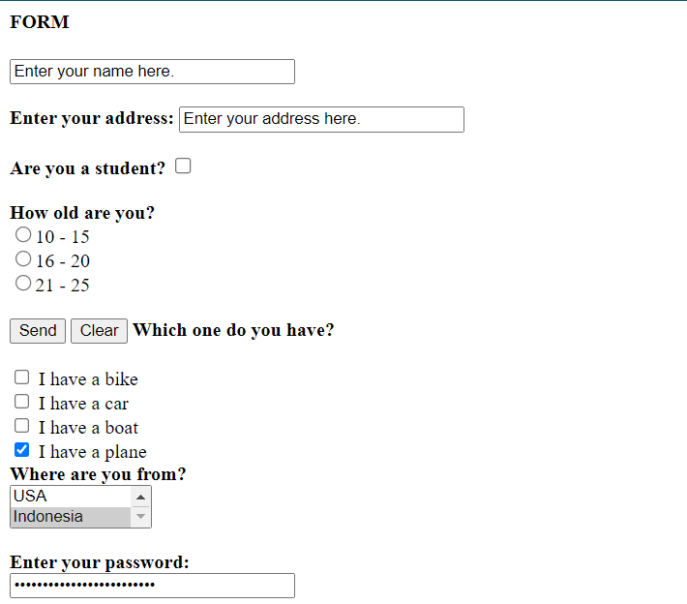

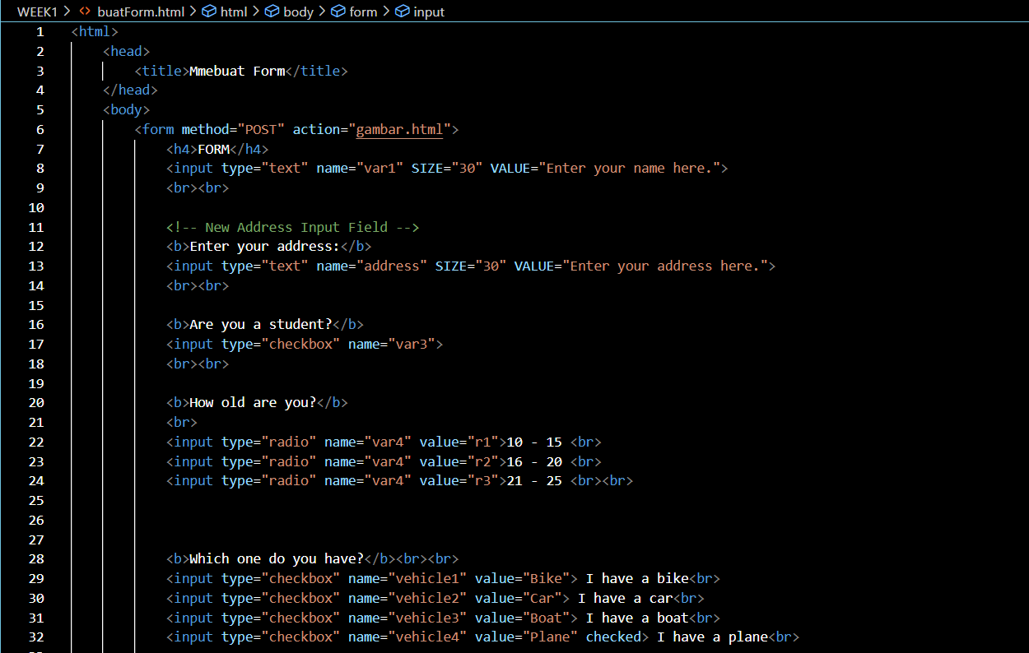

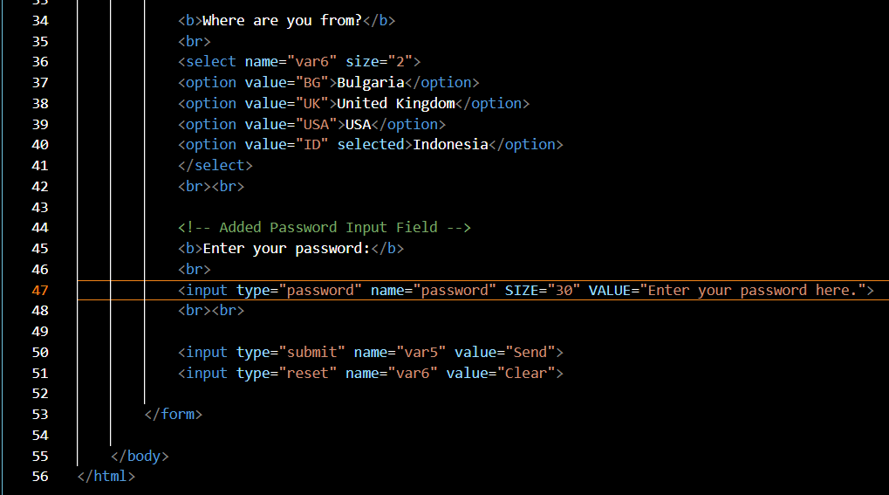

37. From the code in step 28, add a text area for typing long comments using the <textarea> and

</textarea> tags, so that the display will look like this

Please record the code you added in step 29 here (question No. 37). Write your answer here

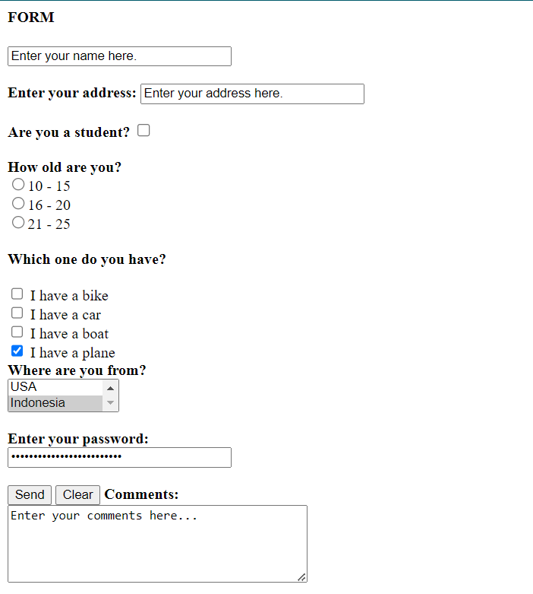

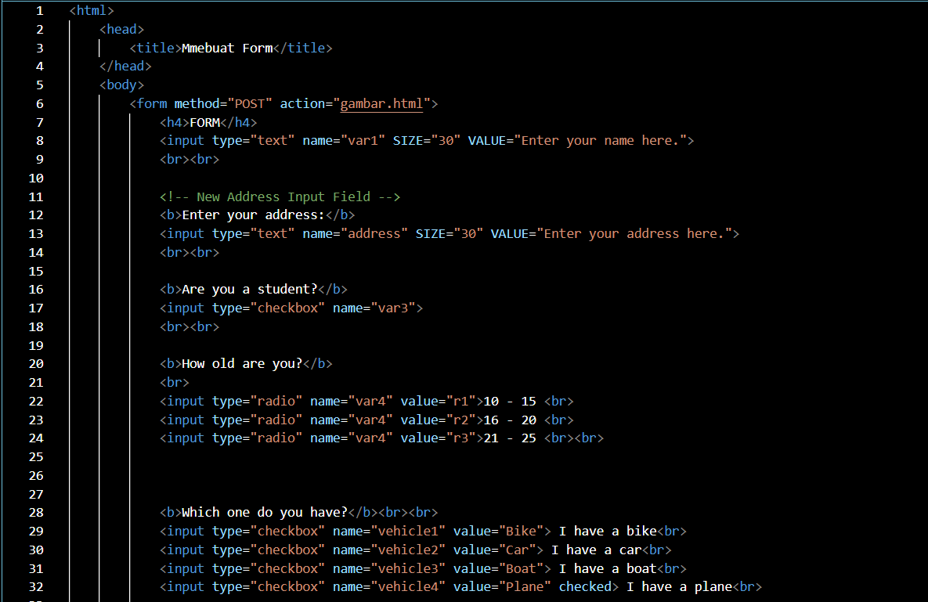

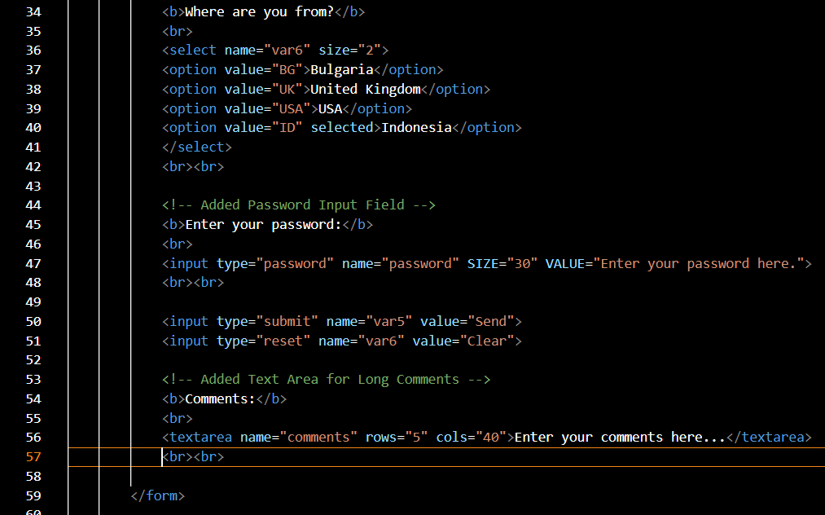

* Added a <textarea> element for user comments with name="comments".
* Set rows="5" and cols="40" to define the size of the text area.
* Included placeholder text "Enter your comments here..." within the <textarea> tags to guide users on what to enter.

This addition allows users to type longer comments or feedback directly into the form.

38. Note your observations here (question No. 38) and write your answer below.

GET  
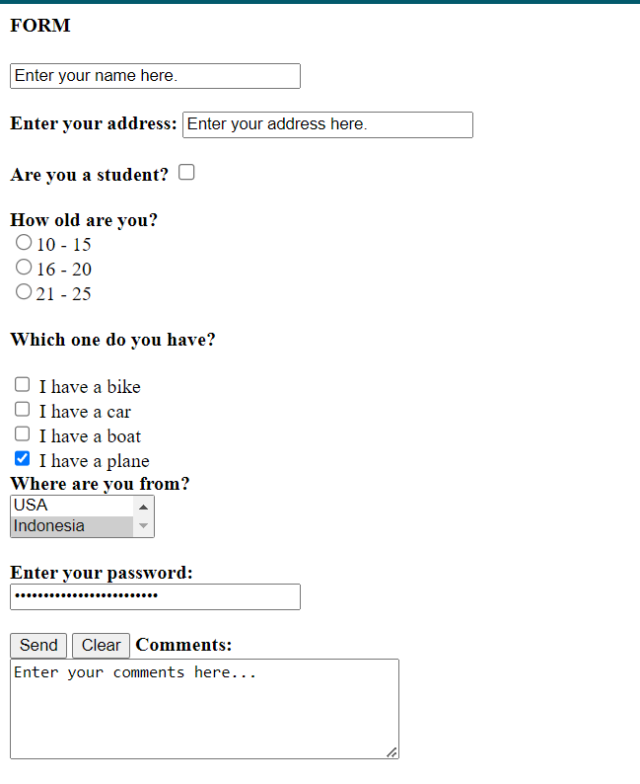

FORM

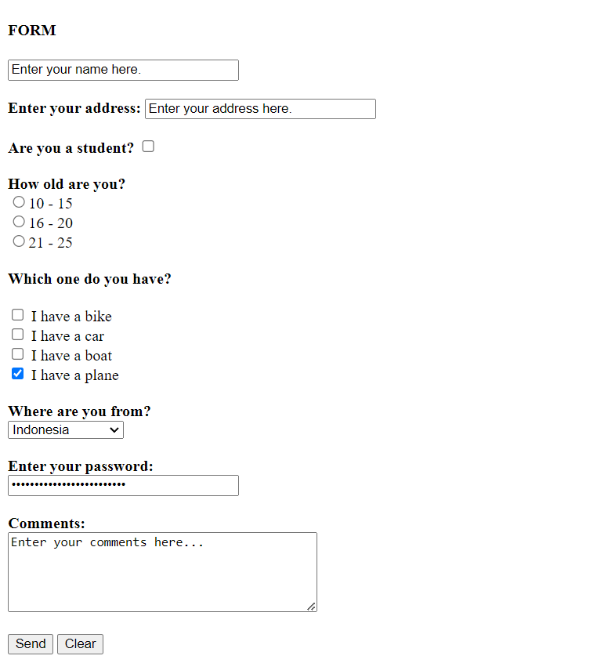

* **POST Method**: Data is sent in the body of the request, URL remains unchanged.
* **GET Method**: Data is appended to the URL as query parameters, making it visible in the address bar.

This will help you observe how each method affects the URL and data transmission when you run the form in your browser.